***The Main Menu:-***

*The system’s main menu is printed the moment you run the program :

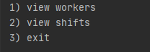

In the main menu you can either view the workers menu , the shift menu or exit the program.

***1)View Workers :***

By choosing this option the system will print a list which represents the workers in the company in the following format :

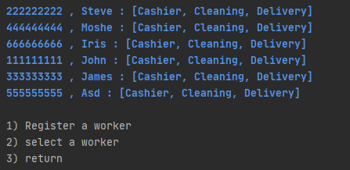

-- Worker ID , Worker Name , [The jobs that the worker can do] --

***1.1) Registering a worker***

If you are interested in adding a new worker to the database choose the “register a worker “ option and it will automatically start a progress which will ask you to fill some essential details and info about the new worker you wish to add. Here is a detailed example:

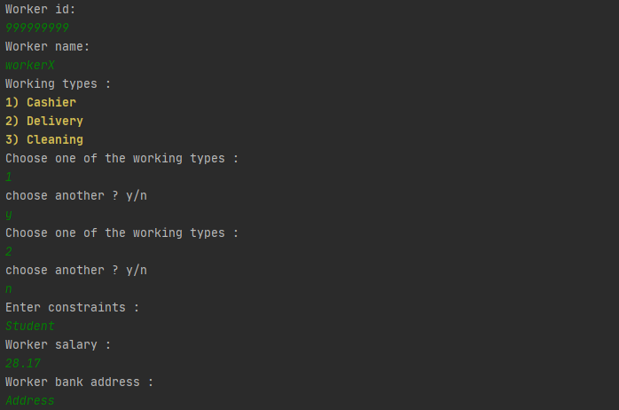

If you wish to allow the worker to work more than one job when asked to “choose another ? y/n “ type “y” and hit Enter , then you can type another number for the “Worker types “ list , you can continue to add job types to the worker and when you decide the its enough type “n” as an answer to the popup “choose another ? y/n.

***Important note***: the registering date of the worker will be the starting date for him in his contract!

After registering the new worker , he should appear in the “ view workers “ list :

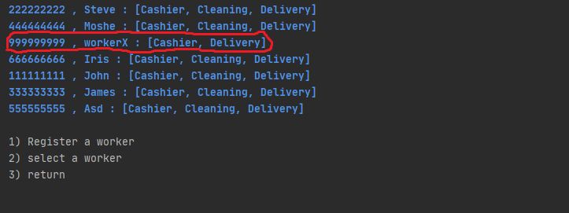

***1.2) Worker info***

if you’re rather interested in viewing more details about the workers ( such as his working shifts , contract etc.) or editing his info then choose the “select a worker option “ , you will be required to type the id of this worker , then the user basic details will be printed on the screen followed by a list options that you can choose from :

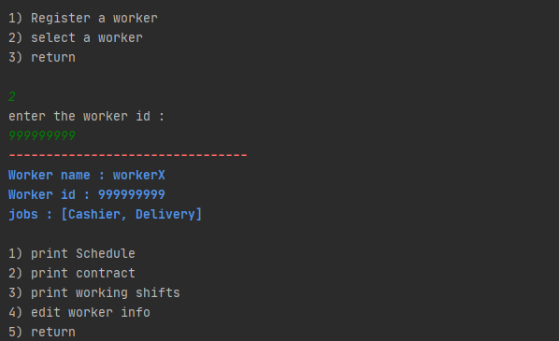

***1.2.1) Print schedule***

to view the worker’s schedule, which represents the time he can work in according to his constraints, select the “print schedule “ option , it will print the schedule in this format :

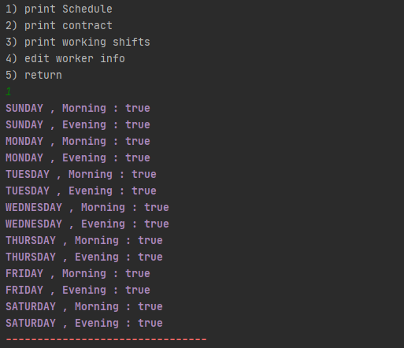

-- Day , Shift Time : CanWork? --

**Note**: canWork? does not mean that the worker is **available**, it means that he can work but maybe he is already signed for a shift at that time.

For more details check the shift view session.

***1.2.2) Print Worker’s Contract***

if you wish to view the worker’s contract, then you should select the “print contract “option , it will be printed in this format :

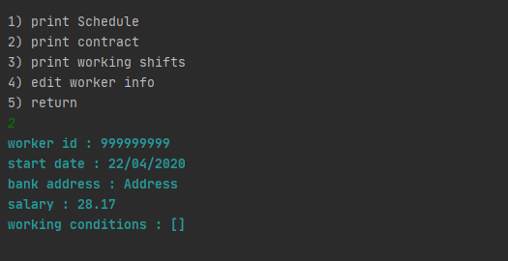

***1.2.3) Print Worker’s Shifts***

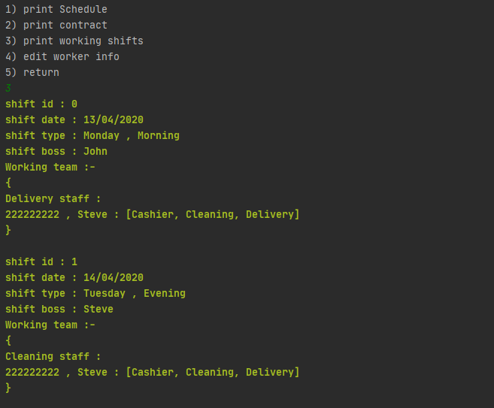to view the shifts that the worker is part of, choose “print working shifts “ :

***1.2.4) Edit worker’s Info***

you can edit the worker’s details using the “edit worker details “ feature , which has a handful of options. Simply choose the desired piece of info you wish to edit and type the new value, you can see the updated worker from the “worker view ” option we saw earlier :

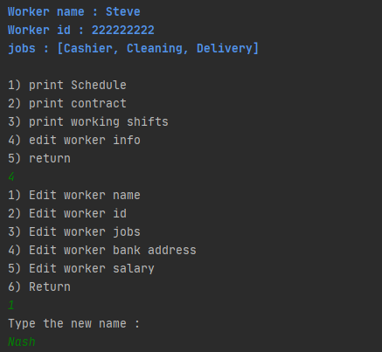

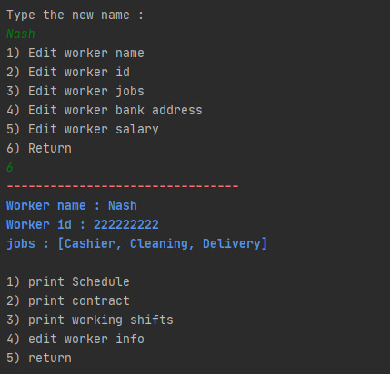Result:

***2)View Shifts***

From the main menu you can view all the shifts:

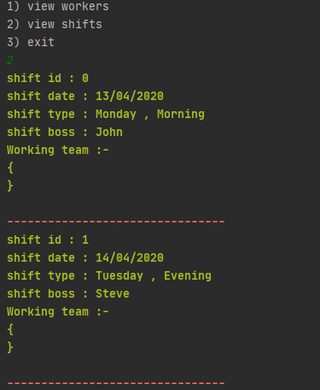

Here we see that there are 2 shifts in the shift history .

***2.1) Add worker to a shift/print available workers for a shift***

you can add workers to a shift by selecting it first , choose the “select shift” option and then type its id , you will be given an open to print the available workers for this shift , alongside which jobs they can do , to do so choose the “print available workers for this shift” option :

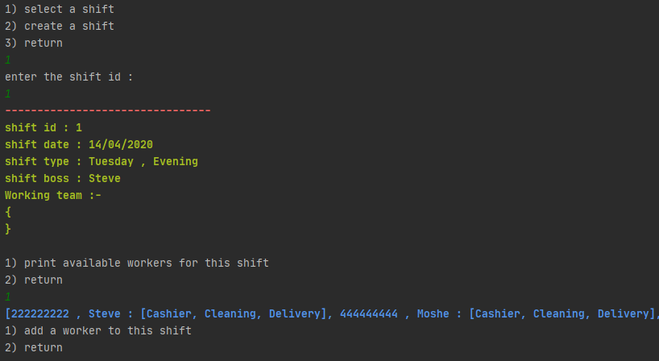

Here we can see that the worker Steve, who has an id number 222222222, is available to work in this shift, he can work as a Cashier , Cleaner or as a delivery guy. If you wish to add him to the shift choose the “add a worker to this shift” option , then type his id , you will then be asked to choose which task he will take in this shift :

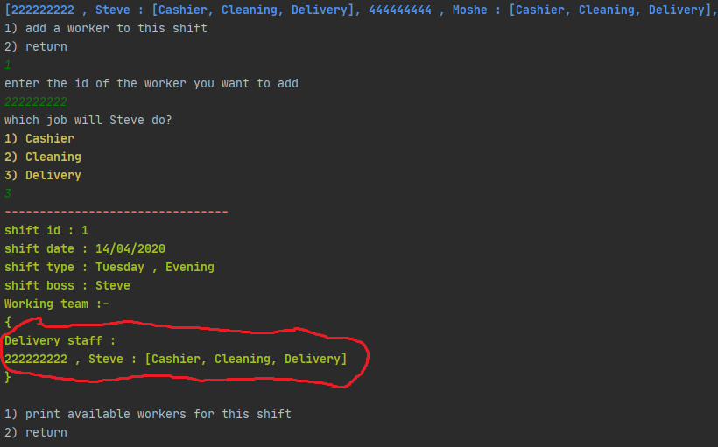

In this example we chose to make Steve a delivery guy, notice that after we asked to add him to the shift he was added to it and to the right staff (Delivery staff).

***A very important note***: even though Steve is the boss in this shift he can also work in it because he is after all a worker , and in supermarkets even the shift boss can take a job ( often a prestigious one ) , but a job is a job :)

***2.2) Create A Shift***

if you wish to make a new shift, choose the “ create a shift “ option from the “view Shifts” menu . you will be asked to enter a few details such as : the shift date (be attention to the format !!) , the shift time(is it morning or evening ?) , and choosing the boss from the available workers at that time , for example :

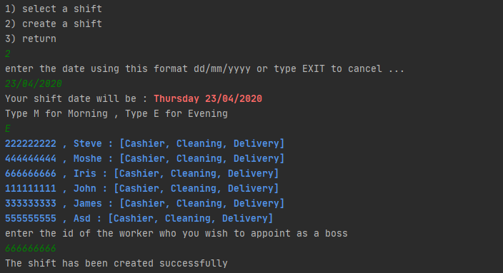

After creating the shift, it should appear in the “View Shifts” menu:

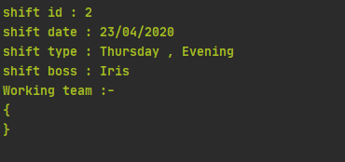

***General important notes:-***

1. Unless its stated otherwise, in order to select an option from a selection menu you should type the number in the beginning.

Number) OPTION

1. When asked to type something into console , DO NOT type a line with any spaces , also please try to stay at the bounds of the options and do not try to test the system’s stability ( for example when asked for salary value type a number , when asked to choose an option from the menu or a list type a positive Integer , unless it is stated otherwise ).
2. For now, a new created worker can work every day at any shift time, regardless what his constraints are.